YUVA INTERN | WEEK 4 TASK
Machine Learning Model Development and Evaluation
Classifying breast tumours as malignant or benign with logistic regression, KNN, decision tree and random forest models

1. Introduction and Problem Definition
Machine learning models learn patterns from past examples so that they can make predictions on new cases. Building one is not just a matter of calling a fit() function: the data must be cleaned and prepared, several algorithms must be compared fairly, performance must be measured on data the model has never seen, and the ways the model can fail must be understood. This report documents that whole process for a medical classification problem.
The task is to predict whether a breast tumour is malignant (cancerous) or benign, using measurements computed from digitised images of a fine-needle aspirate of the breast mass. This is a binary classification problem. It is a good teaching problem because the two kinds of mistake have very different costs, so accuracy alone is not enough to judge a model.

1.1 Success criteria
- Positive class: malignant. A false negative (a cancer predicted as benign) could delay treatment, so it is the more serious error.
- Primary metrics: recall (share of cancers found), F1-score (balance of precision and recall) and ROC AUC (ranking quality across all thresholds).
- Secondary metrics: accuracy and precision. Accuracy alone can hide poor recall on the smaller class.
- Goal: a simple, explainable model that generalises well, which means it performs about as well on new data as on training data.
Note: this is a learning exercise on a public benchmark dataset. The model is not a medical device and must not be used for real diagnosis.

2. Data Description
The Breast Cancer Wisconsin (Diagnostic) dataset from the UCI Machine Learning Repository was used. It is publicly available and is bundled with scikit-learn, so it can be loaded without a download. Each row is one patient sample.
Property | Value
Samples / features | 569 rows, 30 numeric features + 1 target
Features | 10 cell-nucleus measurements (radius, texture, perimeter, area, smoothness, compactness, concavity, concave points, symmetry, fractal dimension), each given as mean, standard error and "worst" (largest) value
Target | Benign (357, 62.7%) or malignant (212, 37.3%)
Missing values / duplicates | 0 / 0

from sklearn.datasets import load_breast_cancer
raw = load_breast_cancer(as_frame=True)
X = raw.data.copy()
y = (1 - raw.target).rename('malignant') # sklearn codes malignant as 0 -> flip so malignant = 1
print(X.shape, X.isna().sum().sum(), X.duplicated().sum()) # (569, 30) 0 0

2.1 Exploratory data analysis
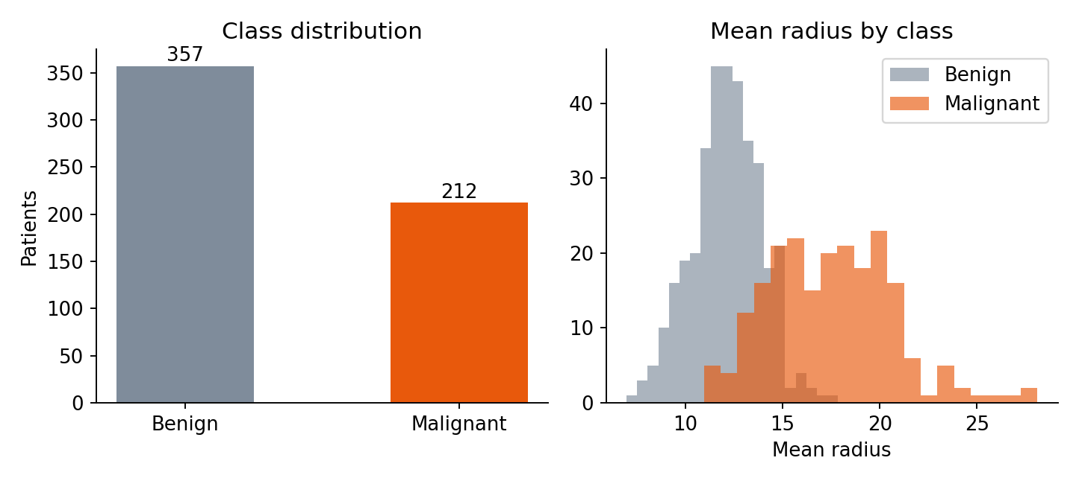
Figure 1: Class balance and mean radius distribution by class
The classes are moderately imbalanced (about 63% benign), which is mild enough that no resampling is needed, but it is the reason a stratified split and recall/F1 are used. Malignant tumours have visibly larger mean radius, which tells us the features carry real signal.
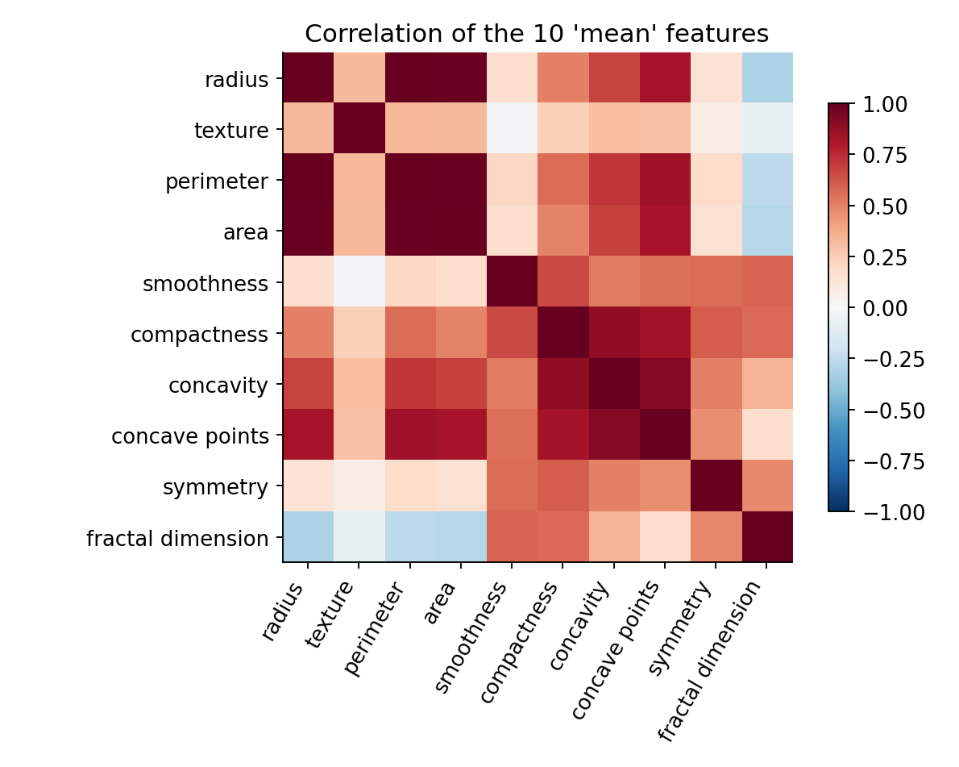
Figure 2: Correlation matrix of the ten "mean" features
Many features are strongly correlated; for example mean radius and mean perimeter have a correlation of 0.998, because perimeter is almost a multiple of radius. This multicollinearity does not harm prediction much but makes individual model coefficients hard to interpret. Several features are also heavily skewed (for instance area error, skewness 5.45) and the features have very different scales, which matters for distance-based and linear models.

3. Data Preparation
- Cleaning checks: no missing values and no duplicate rows were found, so no imputation or removal was necessary.
- Target encoding: scikit-learn codes malignant as 0 and benign as 1. The target was flipped so that malignant = 1, making recall, precision and the confusion matrix refer to cancers.
- Outliers: extreme values were kept. They are genuine measurements of large or irregular tumours, which are exactly the cases that matter, and tree-based models are insensitive to them.
- Train/test split: 80/20 stratified split with a fixed random seed, giving 455 training and 114 test samples (170 and 42 malignant). The test set was not used for any decision until the final evaluation.
- Feature scaling: StandardScaler (zero mean, unit variance) for logistic regression and KNN. It is placed inside a scikit-learn Pipeline so that scaling statistics are computed only from training folds. Fitting the scaler on the whole dataset first would leak information from the test data into training (data leakage) and give over-optimistic results. Tree-based models do not need scaling.
X_tr, X_te, y_tr, y_te = train_test_split(X, y, test_size=0.20,
stratify=y, random_state=42)

# scaling is part of the pipeline, so it is learned from training folds only (no leakage)
model = Pipeline([('scale', StandardScaler()),
('clf', LogisticRegression(max_iter=1000, random_state=42))])

4. Model Selection and Training

4.1 Candidate algorithms and justification
Four simple, widely used algorithms were compared. Starting with a simple, interpretable baseline and adding complexity only if it helps is sound practice, particularly with a small dataset of 569 samples.
Algorithm | Why it was chosen | Main weakness
Logistic Regression | Simple, fast, interpretable linear baseline; outputs probabilities; works well when classes are roughly linearly separable, as with many medical measurements | Cannot capture complex non-linear interactions
K-Nearest Neighbours | Non-parametric; makes no assumption about the data shape; classifies by similarity to known cases | Sensitive to feature scaling and noisy points; slow on large data
Decision Tree | Easy to visualise and explain as a set of rules; handles non-linearity | High variance; overfits easily if grown too deep
Random Forest | Ensemble of many trees; reduces variance and usually strong on tabular data | Less interpretable; can still overfit small data

4.2 Training and validation strategy
Models were compared with stratified 5-fold cross-validation on the training set only. Each model is trained five times, each time validated on a fold it has not seen, and the scores are averaged. This gives a more reliable estimate than a single split and lets us choose a model without touching the test set. Hyperparameters were then tuned with GridSearchCV (also 5-fold, optimising F1 for the malignant class).
cv = StratifiedKFold(n_splits=5, shuffle=True, random_state=42)
scoring = ['accuracy', 'precision', 'recall', 'f1', 'roc_auc']
for name, m in models.items():
s = cross_validate(m, X_tr, y_tr, cv=cv, scoring=scoring)

gs = GridSearchCV(m, grids[name], cv=cv, scoring='f1', n_jobs=-1)
gs.fit(X_tr, y_tr) # tuning uses training data only

Model | Accuracy | Precision | Recall | F1 | ROC AUC
Logistic Regression | 0.974 ± 0.015 | 0.977 ± 0.028 | 0.953 ± 0.040 | 0.964 ± 0.021 | 0.996 ± 0.005
KNN | 0.965 ± 0.019 | 0.988 ± 0.025 | 0.918 ± 0.034 | 0.951 ± 0.026 | 0.987 ± 0.014
Decision Tree | 0.923 ± 0.033 | 0.900 ± 0.041 | 0.894 ± 0.061 | 0.896 ± 0.045 | 0.917 ± 0.038
Random Forest | 0.960 ± 0.016 | 0.958 ± 0.022 | 0.935 ± 0.039 | 0.946 ± 0.023 | 0.988 ± 0.007

Table above: default-parameter 5-fold cross-validation results (mean ± standard deviation across folds). Logistic regression is the strongest and most consistent model; the unconstrained decision tree is clearly the weakest and the most variable.
Model | Tuned hyper-parameters (best found) | CV F1 after tuning
Logistic Regression | C = 1 | 0.964
KNN | n_neighbors = 3 | 0.963
Decision Tree | max_depth = 6, min_samples_leaf = 3 | 0.913
Random Forest | max_depth = 8, min_samples_leaf = 1 | 0.946

Model selection was decided on cross-validated F1 before looking at the test set. Logistic Regression had the highest cross-validated F1 (0.964), so it is the primary candidate.

5. Evaluation on the Test Set
After selection, each tuned model was refitted on the full training set and evaluated once on the 114 held-out test samples.
pred = m.predict(X_te); prob = m.predict_proba(X_te)[:, 1]
cm = confusion_matrix(y_te, pred)
accuracy_score(y_te, pred), precision_score(y_te, pred), recall_score(y_te, pred),
f1_score(y_te, pred), roc_auc_score(y_te, prob)
fpr, tpr, _ = roc_curve(y_te, prob)

Model | Accuracy | Precision | Recall | F1 | ROC AUC | Train acc.
Logistic Regression | 0.965 | 0.975 | 0.929 | 0.951 | 0.996 | 0.987
KNN | 0.939 | 0.973 | 0.857 | 0.911 | 0.982 | 0.985
Decision Tree | 0.930 | 0.925 | 0.881 | 0.902 | 0.972 | 0.971
Random Forest | 0.965 | 1.000 | 0.905 | 0.950 | 0.994 | 1.000

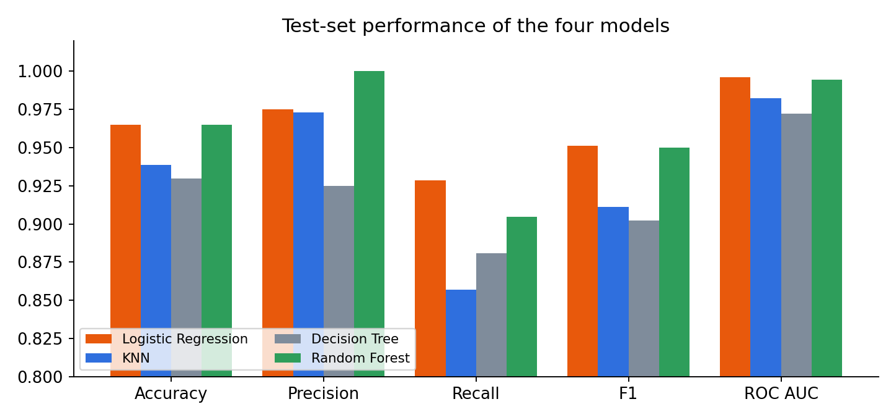
Figure 3: Test-set metrics for the four models

5.1 Confusion matrices
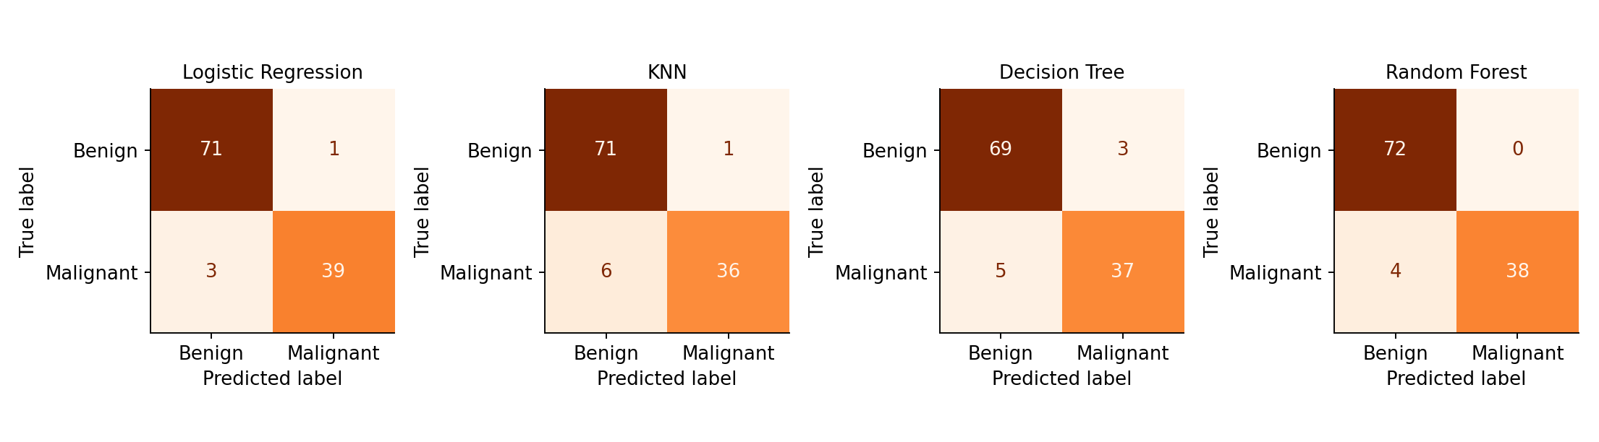
Figure 4: Confusion matrices on the test set (rows = true class, columns = predicted)
Model | True neg. | False pos. | False neg. | True pos. | Missed cancers (FN rate)
Logistic Regression | 71 | 1 | 3 | 39 | 7.1%
KNN | 71 | 1 | 6 | 36 | 14.3%
Decision Tree | 69 | 3 | 5 | 37 | 11.9%
Random Forest | 72 | 0 | 4 | 38 | 9.5%

5.2 ROC curves
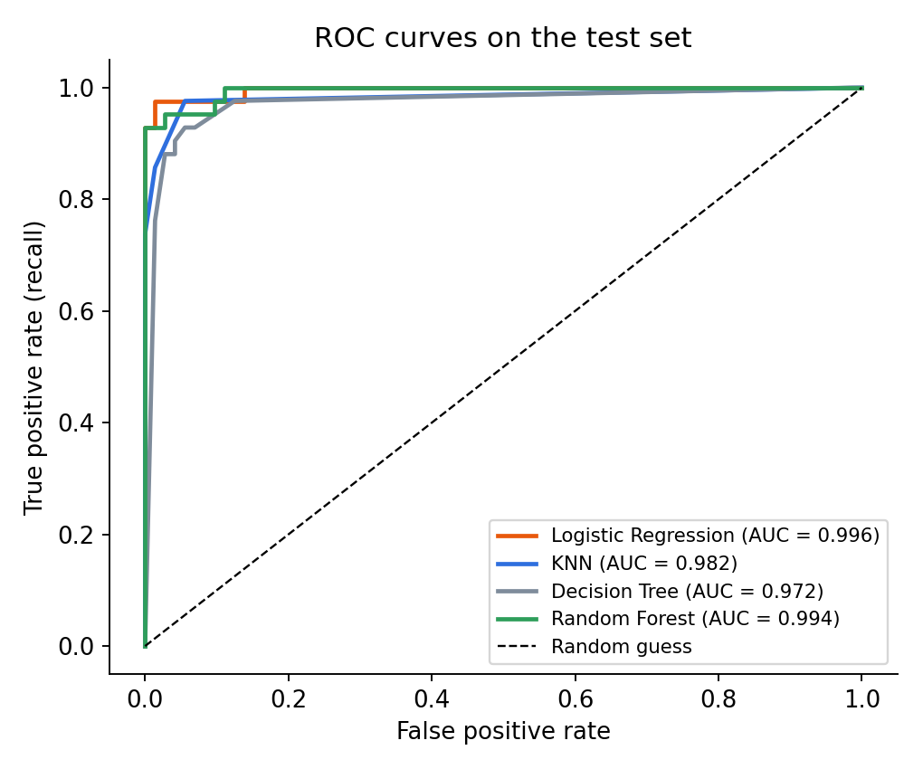
Figure 5: ROC curves of the four models on the test set

5.3 Reading the results
Logistic Regression reached 96.5% accuracy, 97.5% precision, 92.9% recall and an F1 of 0.951, with ROC AUC of 0.996. It made only 4 errors out of 114: 1 false positive (a benign tumour flagged as malignant) and 3 false negatives (cancers missed), a missed-cancer rate of 7.1% and a false-alarm rate of 1.4%. The test results agree with the cross-validation estimate, which is evidence that the model-selection process did not overfit the test data.
Random forest had the same accuracy (96.5%) and perfect precision (no false alarms), but it missed 4 cancers, so its recall (90.5%) is lower. KNN missed 6 cancers and the decision tree had the most false alarms and 5 misses. Because missing a cancer is the costlier error, Logistic Regression is preferred, and it is also the simplest and most explainable. Differences between the top two models are one or two patients, which is within the noise of a small test set (Section 7).

6. Overfitting and Underfitting
A model underfits when it is too simple to capture the pattern, so it does poorly on both training and new data. It overfits when it memorises the training data, including noise, so it does well on training data but worse on new data. The gap between training and validation scores is the key diagnostic.
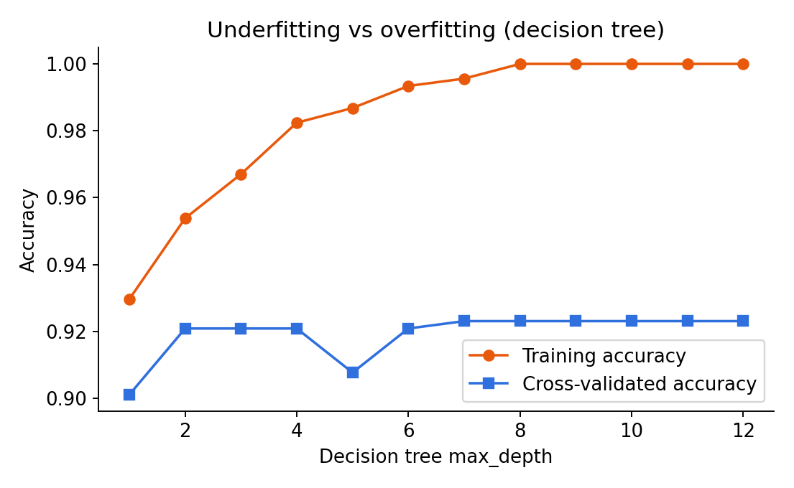
Figure 6: Decision-tree training versus cross-validated accuracy by depth
The decision-tree experiment shows both problems. At depth 1 the tree underfits (training accuracy 0.930, cross-validated 0.901). From depth 8 the tree reaches 100% training accuracy but cross-validated accuracy stays flat at about 0.923: it has memorised the training set, a gap of roughly 7.7 percentage points. Restricting depth and leaf size (tuned best: depth 6, min leaf 3) reduces this.
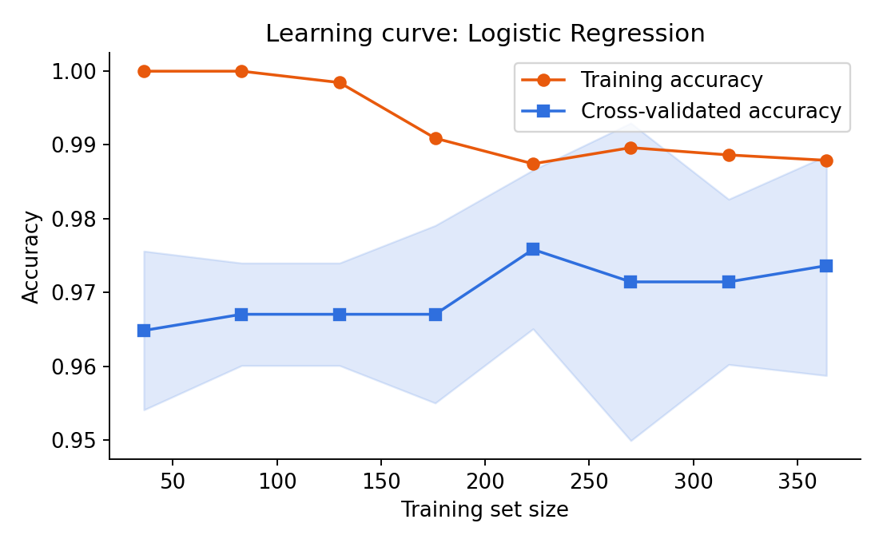
Figure 7: Learning curve of the selected model
For Logistic Regression, training accuracy (0.988) and cross-validated accuracy (0.974) are close, and the test accuracy (0.965) is in the same range, so the model is well fitted with only mild overfitting. The two curves are still slightly apart at the largest training size, which suggests that more data could still help a little. Random forest shows a stronger signature: 100% training accuracy against 0.965 on the test set.

7. Reliability of the Estimate
With only 114 test samples, each single error moves accuracy by about 0.9 percentage points, so one test score can be luck of the split. To check this, the selected model was retrained and evaluated on 10 different random stratified splits. Accuracy averaged 97.3% with a standard deviation of 1.5% and ranged from 93.9% to 99.1%. The honest summary is therefore "about 97% accuracy, give or take 1.5 points", not a precise "96.5%". This is also why small gaps between the top models should not be over-interpreted.

8. Model Interpretation
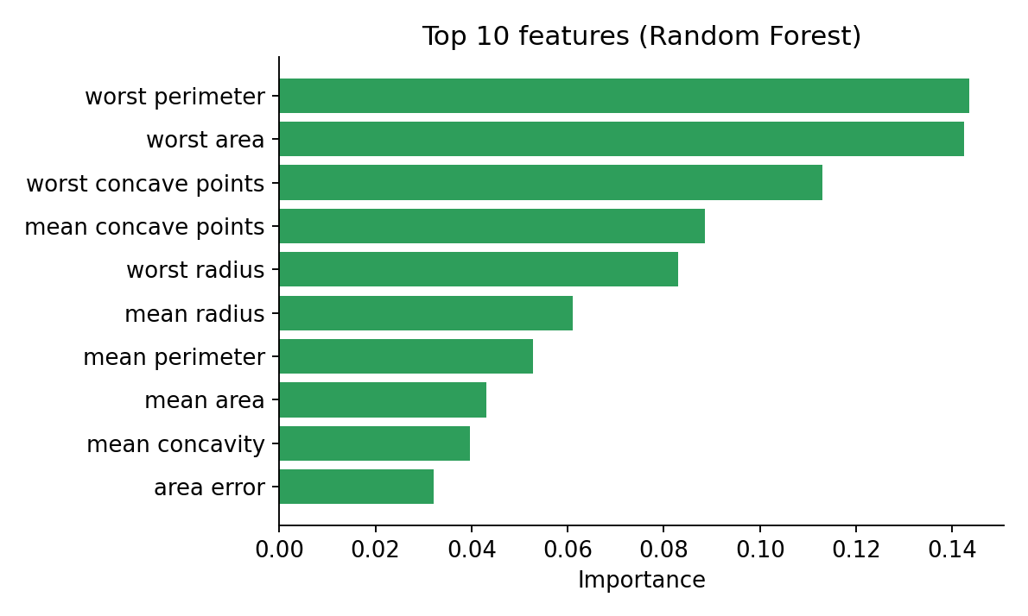
Figure 8: Ten most important features according to the random forest
The random forest ranks worst perimeter, worst area, worst concave points as the most informative features. These describe the size and irregular shape of the largest cells, which agrees with medical intuition that malignant nuclei are larger and more irregular. Logistic regression gives a different top list (worst texture, radius error, worst symmetry, mean concave points); this is expected with strongly correlated features, since a linear model can share weight between related variables arbitrarily. Importance rankings from either model should therefore be read as "these groups of size and shape features matter", not as exact individual effects.

9. Error Analysis
The 4 misclassified test samples of Logistic Regression were examined individually:
Mean radius | Mean concavity | True class | Predicted P(malignant) | Error type
13.38 | 0.028 | Benign | 0.509 | False positive
13.8 | 0.078 | Malignant | 0.061 | False negative
14.22 | 0.198 | Malignant | 0.315 | False negative
15.12 | 0.076 | Malignant | 0.492 | False negative

Three of the four errors have predicted probabilities between 0.3 and 0.52, which means the model was uncertain: these are borderline cases near the decision boundary rather than confident blunders. One missed cancer, however, received a probability of only 0.061, a confident miss, and the tumour is small and has low concavity: it looks benign on these features. Such cases are inherent limits of the data.

9.1 Moving the decision threshold
By default a case is called malignant when the predicted probability is at least 0.5. Because missed cancers are costlier than false alarms, lowering the threshold trades some precision for recall:
Threshold | Precision | Recall | False positives | False negatives
0.5 | 0.975 | 0.929 | 1 | 3
0.4 | 0.976 | 0.952 | 1 | 2
0.3 | 0.976 | 0.976 | 1 | 1
0.2 | 0.911 | 0.976 | 4 | 1
0.1 | 0.891 | 0.976 | 5 | 1

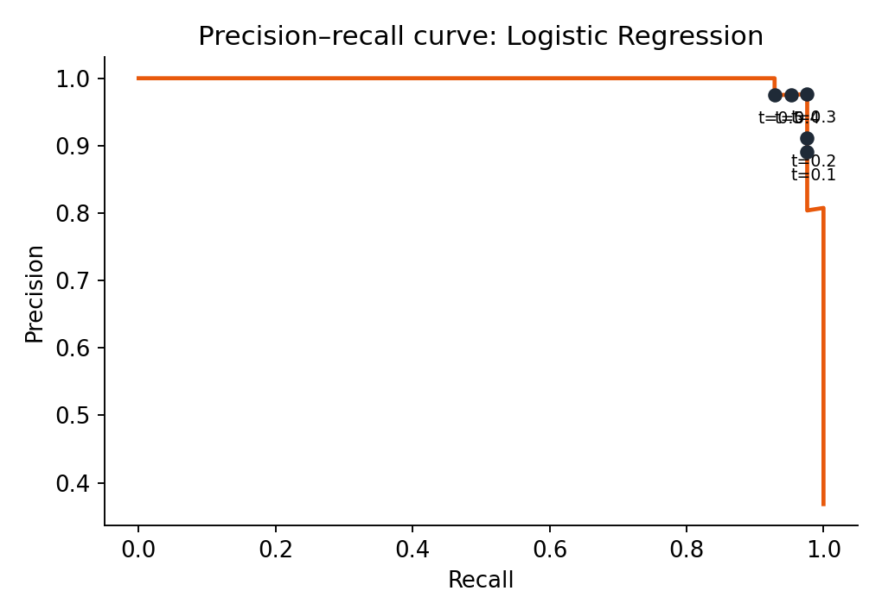
Figure 9: Precision–recall curve with threshold markers
Lowering the threshold to 0.3 would have found one more cancer for no extra false alarms on this test set. This analysis was done on the test set purely for illustration; choosing a threshold by looking at test results is itself a form of leakage and gives an optimistic estimate. In a real project the threshold would be chosen on validation data (for example from cross-validated predictions) and then confirmed once on untouched data.

10. Sources of Error and Suggestions for Improvement

10.1 Potential sources of error
- Small sample size: 569 patients is small; estimates are noisy (Section 7) and complex models are prone to overfitting.
- Single data source: all samples come from one study. Different hospitals, scanners and staining procedures could shift the feature distributions, and performance on such data (distribution shift) would likely be lower.
- Label and measurement noise: diagnosis labels and image-derived measurements both contain some error, which sets a ceiling on achievable accuracy.
- Collinear features: highly correlated features make coefficients unstable and interpretation unreliable.
- Mild class imbalance: fewer malignant examples mean the model sees fewer cancers to learn from.
- Evaluation noise: a 114-sample test set cannot reliably separate models that differ by one or two patients.

10.2 Suggested improvements
- Better validation: use repeated or nested cross-validation and report confidence intervals instead of a single score.
- Threshold and cost-sensitive learning: choose the threshold on validation data or use class weights so that missed cancers are penalised more heavily.
- Probability calibration: calibrate predicted probabilities (Platt scaling or isotonic regression) so that a probability of 0.3 really means a 30% risk.
- Feature work: try regularisation (L1 or elastic net), PCA, or removing redundant features to stabilise the model.
- Other models: compare an SVM, gradient boosting (e.g. XGBoost) and ensembles; they may handle the borderline cases better.
- More and more varied data: add samples from other sources and test on an external dataset before trusting the model.
- Explainability: use tools such as SHAP to explain individual predictions, which clinicians would require.

11. Conclusion
A complete machine learning workflow was carried out: data inspection and preparation, a leakage-safe pipeline, comparison of four algorithms by cross-validation, hyperparameter tuning, a single final evaluation on held-out data, and diagnosis of overfitting, errors and reliability. Logistic Regression proved the best choice: it had the highest cross-validated F1, the highest test recall, F1 and ROC AUC, a small train-to-test gap and the greatest simplicity. It reached 96.5% test accuracy and 92.9% recall with an AUC of 0.996.
Strengths | Limitations
High accuracy, recall and AUC with a simple, explainable model | Small single-source dataset; no external validation
Leakage-safe pipeline; selection done on cross-validation, not on the test set | Test set of 114 gives noisy estimates (about ±1.5 points across splits)
Errors are mostly borderline cases and can be traded off through the threshold | A few cancers are still missed, including one with a very low predicted probability
Reproducible: fixed seeds and complete code provided | Not clinically validated; for learning purposes only

The main lesson is that a good model is not the one with the highest single score, but the one whose performance is measured honestly, understood, and robust to the choice of data split.

Appendix A: Complete Python Code
The script below runs the full pipeline, creates all figures and saves the results. Required libraries: pandas, NumPy, scikit-learn, Matplotlib.
import json
import numpy as np
import pandas as pd
import matplotlib
matplotlib.use("Agg")
import matplotlib.pyplot as plt
from sklearn.datasets import load_breast_cancer
from sklearn.model_selection import train_test_split, StratifiedKFold, cross_validate, GridSearchCV, learning_curve
from sklearn.pipeline import Pipeline
from sklearn.preprocessing import StandardScaler
from sklearn.linear_model import LogisticRegression
from sklearn.neighbors import KNeighborsClassifier
from sklearn.tree import DecisionTreeClassifier
from sklearn.ensemble import RandomForestClassifier
from sklearn.metrics import (accuracy_score, precision_score, recall_score, f1_score, roc_auc_score,
confusion_matrix, roc_curve, precision_recall_curve, ConfusionMatrixDisplay)

SEED = 42
R = {}
plt.rcParams.update({"font.size": 11, "axes.spines.top": False, "axes.spines.right": False})
COL = {"Logistic Regression": "#E8590C", "KNN": "#2F6FDE", "Decision Tree": "#7F8C9B", "Random Forest": "#2E9E5B"}

# ------------------------------------------------------------------
# 1. LOAD DATA (Breast Cancer Wisconsin Diagnostic, UCI) -- malignant = positive class
# ------------------------------------------------------------------
raw = load_breast_cancer(as_frame=True)
X = raw.data.copy()
y = (1 - raw.target).rename("malignant") # sklearn codes malignant as 0; flip so malignant = 1
df = pd.concat([X, y], axis=1)
R["shape"] = list(df.shape)
R["missing_total"] = int(df.isna().sum().sum())
R["duplicates"] = int(df.duplicated().sum())
R["class_counts"] = {"benign": int((y == 0).sum()), "malignant": int((y == 1).sum())}
R["describe_sample"] = X[["mean radius", "mean texture", "mean area", "mean concavity"]].describe().loc[["mean", "std", "min", "max"]].round(2).to_dict()
R["max_skew_features"] = X.skew().sort_values(ascending=False).head(3).round(2).to_dict()
df.to_csv("breast_cancer_dataset.csv", index=False)

# ------------------------------------------------------------------
# 2. EDA FIGURES
# ------------------------------------------------------------------
fig, axs = plt.subplots(1, 2, figsize=(8.5, 3.8))
axs[0].bar(["Benign", "Malignant"], [R["class_counts"]["benign"], R["class_counts"]["malignant"]], color=["#7F8C9B", "#E8590C"], width=0.5)
for i, v in enumerate([R["class_counts"]["benign"], R["class_counts"]["malignant"]]): axs[0].text(i, v + 5, str(v), ha="center")
axs[0].set_title("Class distribution"); axs[0].set_ylabel("Patients")
for lab, c, nm in [(0, "#7F8C9B", "Benign"), (1, "#E8590C", "Malignant")]:
axs[1].hist(X.loc[y == lab, "mean radius"], bins=20, alpha=0.65, color=c, label=nm)
axs[1].set_title("Mean radius by class"); axs[1].set_xlabel("Mean radius"); axs[1].legend()
plt.tight_layout(); plt.savefig("m1_eda.png", dpi=170); plt.close()

corr = X.iloc[:, :10].corr()
fig, ax = plt.subplots(figsize=(7, 5.6))
im = ax.imshow(corr, cmap="RdBu_r", vmin=-1, vmax=1)
ax.set_xticks(range(10)); ax.set_yticks(range(10))
ax.set_xticklabels([c.replace("mean ", "") for c in corr.columns], rotation=60, ha="right")
ax.set_yticklabels([c.replace("mean ", "") for c in corr.columns])
plt.colorbar(im, shrink=0.8); ax.set_title("Correlation of the 10 'mean' features")
plt.tight_layout(); plt.savefig("m2_corr.png", dpi=170); plt.close()
R["corr_radius_perimeter"] = round(float(X["mean radius"].corr(X["mean perimeter"])), 3)

# ------------------------------------------------------------------
# 3. TRAIN / TEST SPLIT (stratified 80/20) -- test set is untouched until final evaluation
# ------------------------------------------------------------------
X_tr, X_te, y_tr, y_te = train_test_split(X, y, test_size=0.20, stratify=y, random_state=SEED)
R["split"] = dict(train=len(X_tr), test=len(X_te), train_malignant=int(y_tr.sum()), test_malignant=int(y_te.sum()))

# ------------------------------------------------------------------
# 4. CANDIDATE MODELS -- scaling lives INSIDE the pipeline to prevent data leakage
# ------------------------------------------------------------------
models = {
"Logistic Regression": Pipeline([("scale", StandardScaler()), ("clf", LogisticRegression(max_iter=1000, random_state=SEED))]),
"KNN": Pipeline([("scale", StandardScaler()), ("clf", KNeighborsClassifier(n_neighbors=5))]),
"Decision Tree": Pipeline([("clf", DecisionTreeClassifier(random_state=SEED))]),
"Random Forest": Pipeline([("clf", RandomForestClassifier(n_estimators=300, random_state=SEED))]),
}
cv = StratifiedKFold(n_splits=5, shuffle=True, random_state=SEED)
scoring = ["accuracy", "precision", "recall", "f1", "roc_auc"]
cv_rows = {}
for name, m in models.items():
s = cross_validate(m, X_tr, y_tr, cv=cv, scoring=scoring)
cv_rows[name] = {k: (float(s[f"test_{k}"].mean()), float(s[f"test_{k}"].std())) for k in scoring}
R["cv_baseline"] = cv_rows

# ------------------------------------------------------------------
# 5. HYPERPARAMETER TUNING (grid search with 5-fold CV on training data only, optimising F1)
# ------------------------------------------------------------------
grids = {
"Logistic Regression": {"clf__C": [0.01, 0.1, 1, 10, 100]},
"KNN": {"clf__n_neighbors": [3, 5, 7, 9, 11, 15]},
"Decision Tree": {"clf__max_depth": [2, 3, 4, 5, 6, 8, None], "clf__min_samples_leaf": [1, 3, 5]},
"Random Forest": {"clf__max_depth": [4, 8, None], "clf__min_samples_leaf": [1, 3]},
}
tuned, best_params, tuned_cv = {}, {}, {}
for name, m in models.items():
gs = GridSearchCV(m, grids[name], cv=cv, scoring="f1", n_jobs=-1)
gs.fit(X_tr, y_tr)
tuned[name] = gs.best_estimator_
best_params[name] = {k.replace("clf__", ""): v for k, v in gs.best_params_.items()}
tuned_cv[name] = float(gs.best_score_)
R["best_params"] = best_params
R["tuned_cv_f1"] = tuned_cv
best_name = max(tuned_cv, key=tuned_cv.get)
R["best_model_by_cv"] = best_name

# ------------------------------------------------------------------
# 6. TEST SET EVALUATION
# ------------------------------------------------------------------
test_rows, probs, cms = {}, {}, {}
for name, m in tuned.items():
m.fit(X_tr, y_tr)
pred = m.predict(X_te); pr = m.predict_proba(X_te)[:, 1]
probs[name] = pr
cms[name] = confusion_matrix(y_te, pred)
test_rows[name] = dict(accuracy=accuracy_score(y_te, pred), precision=precision_score(y_te, pred),
recall=recall_score(y_te, pred), f1=f1_score(y_te, pred), auc=roc_auc_score(y_te, pr),
train_acc=accuracy_score(y_tr, m.predict(X_tr)),
tn=int(cms[name][0, 0]), fp=int(cms[name][0, 1]), fn=int(cms[name][1, 0]), tp=int(cms[name][1, 1]))
R["test"] = test_rows

# Fig 3: confusion matrices
fig, axs = plt.subplots(1, 4, figsize=(13, 3.6))
for ax, (name, cm) in zip(axs, cms.items()):
ConfusionMatrixDisplay(cm, display_labels=["Benign", "Malignant"]).plot(ax=ax, cmap="Oranges", colorbar=False, values_format="d")
ax.set_title(name, fontsize=11)
plt.tight_layout(); plt.savefig("m3_confusion.png", dpi=170); plt.close()

# Fig 4: ROC curves
fig, ax = plt.subplots(figsize=(6, 5))
for name, pr in probs.items():
fpr, tpr, _ = roc_curve(y_te, pr)
ax.plot(fpr, tpr, lw=2, color=COL[name], label=f"{name} (AUC = {test_rows[name]['auc']:.3f})")
ax.plot([0, 1], [0, 1], "k--", lw=1, label="Random guess")
ax.set_xlabel("False positive rate"); ax.set_ylabel("True positive rate (recall)"); ax.set_title("ROC curves on the test set")
ax.legend(loc="lower right", fontsize=9)
plt.tight_layout(); plt.savefig("m4_roc.png", dpi=170); plt.close()

# Fig 5: metric comparison bars
metrics = ["accuracy", "precision", "recall", "f1", "auc"]
fig, ax = plt.subplots(figsize=(8.5, 4))
w = 0.2
for i, (name, row) in enumerate(test_rows.items()):
ax.bar(np.arange(len(metrics)) + i * w, [row[m] for m in metrics], w, color=COL[name], label=name)
ax.set_xticks(np.arange(len(metrics)) + 1.5 * w); ax.set_xticklabels(["Accuracy", "Precision", "Recall", "F1", "ROC AUC"])
ax.set_ylim(0.8, 1.02); ax.set_title("Test-set performance of the four models"); ax.legend(ncol=2, fontsize=9, loc="lower left")
plt.tight_layout(); plt.savefig("m5_metrics.png", dpi=170); plt.close()

# ------------------------------------------------------------------
# 7. OVERFITTING / UNDERFITTING: decision-tree depth curve and learning curve of final model
# ------------------------------------------------------------------
depths = list(range(1, 13))
tr_acc, cv_acc = [], []
for d in depths:
t = DecisionTreeClassifier(max_depth=d, random_state=SEED)
tr_acc.append(t.fit(X_tr, y_tr).score(X_tr, y_tr))
cv_acc.append(cross_validate(t, X_tr, y_tr, cv=cv)["test_score"].mean())
R["depth_curve"] = dict(depths=depths, train=[round(a, 4) for a in tr_acc], cv=[round(a, 4) for a in cv_acc])
fig, ax = plt.subplots(figsize=(6.5, 4))
ax.plot(depths, tr_acc, "o-", color="#E8590C", label="Training accuracy")
ax.plot(depths, cv_acc, "s-", color="#2F6FDE", label="Cross-validated accuracy")
ax.set_xlabel("Decision tree max_depth"); ax.set_ylabel("Accuracy"); ax.set_title("Underfitting vs overfitting (decision tree)")
ax.legend(); plt.tight_layout(); plt.savefig("m6_depth.png", dpi=170); plt.close()

final = tuned[best_name]
sizes, ltr, lcv = learning_curve(final, X_tr, y_tr, cv=cv, train_sizes=np.linspace(0.1, 1.0, 8), scoring="accuracy", random_state=SEED)
fig, ax = plt.subplots(figsize=(6.5, 4))
ax.plot(sizes, ltr.mean(1), "o-", color="#E8590C", label="Training accuracy")
ax.plot(sizes, lcv.mean(1), "s-", color="#2F6FDE", label="Cross-validated accuracy")
ax.fill_between(sizes, lcv.mean(1) - lcv.std(1), lcv.mean(1) + lcv.std(1), color="#2F6FDE", alpha=0.15)
ax.set_xlabel("Training set size"); ax.set_ylabel("Accuracy"); ax.set_title(f"Learning curve: {best_name}")
ax.legend(); plt.tight_layout(); plt.savefig("m7_learning.png", dpi=170); plt.close()
R["learning_curve_last"] = dict(train=float(ltr.mean(1)[-1]), cv=float(lcv.mean(1)[-1]))

# ------------------------------------------------------------------
# 8. INTERPRETATION: feature importance of final model, error analysis, threshold analysis
# ------------------------------------------------------------------
rf = tuned["Random Forest"].named_steps["clf"]
imp = pd.Series(rf.feature_importances_, index=X.columns).sort_values(ascending=False).head(10)
R["rf_top"] = imp.round(3).to_dict()
fig, ax = plt.subplots(figsize=(7, 4.2))
ax.barh(imp.index[::-1], imp.values[::-1], color="#2E9E5B")
ax.set_xlabel("Importance"); ax.set_title("Top 10 features (Random Forest)")
plt.tight_layout(); plt.savefig("m8_importance.png", dpi=170); plt.close()

pr_final = probs[best_name]
pred_final = (pr_final >= 0.5).astype(int)
err = X_te.copy(); err["true"] = y_te.values; err["prob_malignant"] = pr_final.round(3); err["pred"] = pred_final
err = err[err.true != err.pred][["mean radius", "mean concavity", "true", "prob_malignant", "pred"]]
R["errors"] = err.round(3).reset_index(drop=True).to_dict("records")

prec, rec, thr = precision_recall_curve(y_te, pr_final)
th_rows = []
for t in [0.5, 0.4, 0.3, 0.2, 0.1]:
p_ = (pr_final >= t).astype(int)
th_rows.append(dict(threshold=t, precision=precision_score(y_te, p_), recall=recall_score(y_te, p_),
fp=int(((p_ == 1) & (y_te.values == 0)).sum()), fn=int(((p_ == 0) & (y_te.values == 1)).sum())))
R["threshold"] = th_rows
fig, ax = plt.subplots(figsize=(6, 4.2))
ax.plot(rec, prec, color="#E8590C", lw=2)
for r_ in th_rows:
ax.scatter(r_["recall"], r_["precision"], color="#1F2A37", zorder=5)
ax.annotate(f"t={r_['threshold']}", (r_["recall"], r_["precision"]), textcoords="offset points", xytext=(-8, -14), fontsize=8)
ax.set_xlabel("Recall"); ax.set_ylabel("Precision"); ax.set_title(f"Precision–recall curve: {best_name}")
plt.tight_layout(); plt.savefig("m9_pr.png", dpi=170); plt.close()

# Random-seed stability of the final model: 10 different splits
accs = []
for s in range(10):
a, b, c_, d_ = train_test_split(X, y, test_size=0.2, stratify=y, random_state=s)
accs.append(final.fit(a, c_).score(b, d_))
R["stability"] = dict(mean=float(np.mean(accs)), std=float(np.std(accs)), min=float(np.min(accs)), max=float(np.max(accs)))
final.fit(X_tr, y_tr)

if best_name == "Logistic Regression":
coefs = pd.Series(final.named_steps["clf"].coef_[0], index=X.columns).sort_values(key=abs, ascending=False).head(6)
R["lr_top_coefs"] = coefs.round(3).to_dict()

def clean(o):
if isinstance(o, dict): return {str(k): clean(v) for k, v in o.items()}
if isinstance(o, (list, tuple)): return [clean(v) for v in o]
if isinstance(o, (np.floating, float)): return float(o)
if isinstance(o, np.integer): return int(o)
return o
json.dump(clean(R), open("ml_results.json", "w"), indent=1, default=str)
print(json.dumps(clean(R), indent=1, default=str))

Appendix B: References
- Wolberg, W. H., Street, W. N., & Mangasarian, O. L. Breast Cancer Wisconsin (Diagnostic) Data Set. UCI Machine Learning Repository.
- Pedregosa, F. et al. (2011). Scikit-learn: Machine Learning in Python. Journal of Machine Learning Research, 12, 2825–2830.
- Hastie, T., Tibshirani, R., & Friedman, J. (2009). The Elements of Statistical Learning (2nd ed.). Springer.
- Fawcett, T. (2006). An introduction to ROC analysis. Pattern Recognition Letters, 27(8), 861–874.
- scikit-learn documentation: https://scikit-learn.org/stable/

